Chapter 1
INTRODUCTION
In the world of business, sales and inventory report has one of the biggest roles in the field of business industry. Recording data from past to present will calculate every statement and will help in monitoring the status of the business. Manual data recording of sales and inventory data are now a thing of the past. Indeed, the world is now inconceivable without computers. Billions of important data can now be stored and handily retrieved because of the database technologies that exists today. Precious time should be in properly manage in order to do all the things that the company or business has. Monitoring and managing the sales and inventory is a hard task for the manager or the owner.

As the world moves further and faster into a thriving technological age, so must the way we conduct our business. The Point-Of-Sale (POS) has been created by IT professionals to make the system of the business easy to manage. It calculates the sales for the day, month and year. And, inventory system programs now on the market lets you track the usage, monitor changes in unit costs, calculate it when you need to reorder, and analyze inventory levels in item-by-item basis. It can even control inventory right at the cash register with point-of-sale (POS) systems. Point-of-Sale System records each sale when it happens, and the inventory records are updated automatically. Growing technology has a limitless development, one of the popular IT Developers companies who transformed Manual Point-of-Sale recording into a more convenient and easy way on recording the sales per day is International Business Management (IBM) it is the best sample why do companies mostly trusted to help manage their client’s business/ company.
PROJECT CONTEXT

AJ Trading Motorparts is one of the well-known motorparts shop here in Tarlac. They sell motorparts and provide some mechanical services that is needed by the customer. It has another branch at San Vicente Tarlac City. AJ Trading Motorparts is in service for 20 years, until now they still have a lot of customers even if there are so many new motorparts shop located in their vicinity. But AJ Trading Motorparts still lacks on innovative technology. When making sales the employee looks for the product on their stands then search their current product list to know its price, he/she will write down the customer’s details on the receipt and then manually computes using a calculator, it takes about 5 minutes per customer. When new items or stock comes, the manager will just write it down on his log book that he had received the quantity of the new items and notifies the owner then put the items on the stands. They don’t have real time monitoring on their current stocks they just rely on what is on their stands. It has no Point of Sale nor an Inventory System and only relying on manual paper based system making it a perfect example for the studies of the researchers. The researchers aim to develop a Point of Sale and Inventory System for AJ Trading Motorparts that will automate the process of the said branches (sales) and gives the admin or manager a reliable inventory storing of products and stocks. The system will also be a computerized solution to the different problem i.e. (unreliable records due to erroneous or unreadable handwriting and loss of records) encountered because of its paper-based system.

Point of Sale and Inventory System are used for accurate business reports and for consistent and secured data storing. The researchers intend to find an innovative point of sale and inventory system. Thus, developing a customized Point of Sale and Inventory System that will solve the problems encountered by AJ Trading Motorparts in its business processes.
The system will aid the existing problems regarding to the Point of Sale, Inventory and Monitoring of the business. It will lessen the time and effort of both employees and manager on storing, retrieving and monitoring of records of the business. The system’s database is more secure and reliable than the traditional paper-based system making loss of records evitable and giving the employees easier management of records.

The users can access the systems through their username and password. Manager account will be default in the system which he can change its password if he wants to. Employee accounts should be created by the Manager and a separate account for the owner of the business that will be used to access the monitoring system.

PURPOSE AND DESCRIPTION

The researchers hoped that the findings of the study will be beneficial to the AJ Trading Motorparts management. This study will serve as a valuable reference to the better development of Business IT System on various managing techniques and services for businesses.
The researchers will develop a system that would provide greater benefits and ease of use to the Manager and Employees of AJ Trading Motorparts. The develop system will be a big help especially in the sales transaction and monitoring of the business. It will also speed up the processes and will help its employees by saving their time and effort on preparing sales record and transaction for the day.
The develop system will give Point of Sale and Inventory functions such as searching through list of products from the inventory and automatic computing its price and total value based on the quantity being sold. The Manager can add, update, delete products in the inventory and also add stocks to products when receiving stocks of the said product.
The develop system can create accounts to be used by employees on the Point of Sale using the manager feature of the system. The system will generate sales report to be viewed by the manager of the business along with the inventory and transaction record of the system to have a data transparency between the management of the AJ Trading Motorparts.

STATEMENT OF OBJECTIVES
The Study was initiated in order to develop a system to be called “Point of Sale and Inventory System” for AJ Trading Motorparts.
- To develop a Point of Sale and Inventory System for the branches of AJ Trading Motorparts with the following modules:
1.1. Manager Module
1.2. Main Register Module
1.3. Inventory Module
1.4. Reports Module
- To validate the effectiveness of the Point of Sale and Inventory System for AJ Trading Motorparts by:
2.1. IT Experts
2.1.1 Efficiency of the System
2.1.2 Security of Information
2.1.3 Database Design
2.2. System Users (Manager, Employee)
2.2.1 Easiness of Use
2.2.2 System Accessibility
2.2.3 Accuracy of Reports

SCOPE AND LIMITATION
The study primarily aimed to design a Point of Sale and Inventory System for AJ Trading Motorparts. The system focuses on the business processes of the branches which includes; Point-of-Sale, automatic computing of sales for the day, employee management, and inventory report.
The Manager Account can add Employee Accounts. The System have a Main Register that acts as Point of Sale and Cash Register. It can create new sale or discard one, computes total purchase, cash receive and change, and the system can only accept cash payments. Sales are then logged on the Sales history for the employee so he/she can monitor his/her transactions made. Only the Manager Account can Add/Update/Delete Products in the system but with the consent of the Owner and Employees for transparency. All products have tags and brands so searching is more efficient. The System will also provide list of products and their respective prices. The system will generate timely and accurate Reports and print them if needed (Sales for the Day and Inventory Report) are accessible to the Manager for monitoring purpose as long as they are logged-in on the system. The scope of the developed system will only be within the said local only.
The limitations of the system are as stated, the system does not support barcode scanning and does not accept payments through credit cards. It can display the receipt of the transaction but does not print it. Lastly returning and exchanging of sold item/s when customer made an error of purchasing an item is not supported by the system.

DEFINITION OF TERMS
The following technical terms used in the study to aid the reader to better understand the research.
Accuracy of Reports. This refers to the accuracy of the reports that are calculated by the system.
Database Design. This is the process of producing a detailed data model of a database. This logical data model contains all the needed logical and physical design choices and physical storage parameters needed to generate a design in a data definition language, which can then be used to create a database.
Ease of Use. This refers to the comfort of using the system that it does not need formal training for the system to be used.
Effectiveness of the System. This measures the effectiveness of the system in automating the processes of the said branch and the capability of the users to adapt the system.
Inventory. Refers to the product or items that are currently in hand. It is use to monitor stocks that are low on quantity and stocks that needs ordering.
POS. Point of Sale used for making sales, displaying the products quantity and price. It also acts as a cash register for payment management.
Receipt. Summary of the sale, it includes the product, quantity, total price, money rendered, change customer name and the sales ID.
System Accessibility. It refers to the accessibility of the system of accounts that have different features and purpose that are protected by personal passwords.

CHAPTER II
REVIEW OF RELATED LITERATURE AND STUDIES

This chapter presents the literature and studies that supplied background information to the study of the researchers.

Foreign Literature
As defined by Carolina Barcode Inc., a Point-of-Sale system is a computer software and hardware networked together to track sales and inventory as they occur. Point-of-Sale systems will solve a multitude of problems in your business. It is one of the focal points of any retail or hospitality business in the cash register. The ability to process transactions and tender cash are essential to the efficient operation of the enterprise. If you have a lot of cash transactions, replacing the cash registers with a Point-Of-Sale (POS) system save you money (2013).
The researchers propose system that has the functionality of a POS and the ability to manage your stocks by an Inventory System.
As stated in the book entitled Introduction to Information System by Ralph Stair and George Reynolds. Purchasing Systems is the traditional Transaction processing system that support the purchasing business function including inventory control, purchase and order processing. This integrated set of systems enables an organization to plan, manage, track and pay for its purchases of raw materials parts and services.
The researchers propose a system that will process fast automated transactions and create reliable sales report of every day, month, and year automatically on a day to day basis. The researchers develop a system that creates transaction report or log that will help on tracking transactions when needed.
According to the U.S. Small Business Administration, “Inventory refers to stocks of anything necessary to do business” (U.S. Small Business Administration, 2010) The U.S. Small Business Administration publication describes what constitutes successful inventory management balancing cost versus benefits of inventory, including Maintaining a wide assortment without spreading the rapidly moving items too thin, Increasing inventory turnover without sacrificing service, Keeping stock low without sacrificing performance, Obtaining lower prices by making volume purchases, Maintaining an adequate inventory without an excess of obsolete items.
The researchers propose a system that will create accurate and informative sales and inventory reports pointing out to the products that needs stock and the products that needs to lower stocks.

Local Literature
According to Gemma Navarro (2012) Computer is general purpose device which can be programmed to carry out a finite set arithmetic or local operation. Computer has a big rule in our nation today because of our technology. Wherever you go computer still exist, especially in business it makes the procedure easy and secure by programming the manual system into a computerizing system. The rule of technology in our life today has a big impact.
The researchers propose a system that has features and functions based on their current manual based system.
In this study conducted by Ariel Magat, he stated that the Inventory System of the vital to any institution, agency, or department. The proper safekeeping, processing and disposal of records play important roles in the efficient, effective and smooth operation that eventually would lead to the success attainment of the goal and objectives of institution, agency and department concerned.
The researchers propose a secure and reliable inventory system storing consistent data and only showing it to the people who has access to it.
In the study from Averion, Gaela, and Libo (2009) it stated that inventory system help to minimize the difficulty of the manager in processing inventory because physical counting products, stocks and computing inventory summary will be the system job. It will monitor the availability of products, items to prevent under stocking, over stocking and running out of stocks. The system will also simplify the transaction between dealer and supplier relationship because of the updated supplier information and price list of items will correspond to collaboration with other supplier.”
The researchers propose a system similar to the article that automatically counts the current inventory when needed faster and efficient.

Foreign Studies
According to the thesis of Carlo Magno “There was a ground swell to move from paper signature and documents because the task of record management was huge. We had file cabinets full of backup materials. By converting from manual process, we would be able to eliminate a lot of paper. We could go further with the automation of manual process and remove manual paperwork if people trusted the technology.
According to Mike Toland “We need a better tracking system than excel spreadsheets and paper”. Paper is too cumbersome and also too limiting, you’ll never know how to specify all the information that you need.
The researchers propose a system that can store data securely by the use of a local database on the locales computer.

Inventory System
By: Wal-Mart
Wal-Mart runs its stores on a perpetual inventory system. This system records the quantity of items sold as items are purchased. The computer system at Wal-Mart constantly keeps up with additions or deductions from inventory and tells management what items are on hand. The organization also conducts counts of employee manual counts of inventory periodically. When an item arrives at the Wal-Mart distribution center it is scanned into the inventory system. When the items are purchased by the consumer, the point-of-sale system reduces the inventory from that purchase. According to Wal-Mart’s Gail Lavielle, a leaner inventory will help clear out store clutter and help Wal-Mart focus on specific brands and products that consumers want.
The researchers propose a system that generates report that are manageable trough fast searching of records of the proposed system.
Local Studies
A study conducted by Mr. Gragasin(2010) et,al. Entitled “A customized Point of Sale and Inventory System for Anespee Enterprise Hardware Carangian” concluded that the implementation of the Developed system increases the business efficiency and effectively in terms of every transaction that they have. Managing the records such as employee, customer, suppliers and transaction is faster and easier than using the manual paper based system.
The researchers propose a customized system that would likely be adapted by the locale to speed up its processes and increase the efficiency of the business.
According to J.De Leon and M. Ferrer (2009) Under the Koread RedGinseng Enterprise Sales and Inventory System, the researchers came up with acomputerized sales and inventory system. The proponents used database toeasy access of files and for easier and faster processing of the selling andinventory transaction. The program was designated to generate reports such asmonthly reports, inventory reports, sales invoice and list of items.
The researchers propose a system that can store data securely by the use of a local database on the locales computer.
Based on the research entitled “Computerized Sales and Inventory systemfor Ronmon Trading” (de Alday, Espino, Ragudo),2010, the replacement of themanual system with the proposed system provided more efficient and accurateprocessing of transaction. The said system is much reliable, eliminated errorsand inaccurate information, and provided valuable reports with integrity.
The researchers propose a system that generates report that are manageable trough fast searching of records of the proposed system.

Chapter 3
TECHNICAL BACKGROUND

This chapter intends to identify the technical background of the locale’s existing system and the software and hardware requirements in order to develop the proposed system.

Technical Background
The Point of Sale and Inventory System will aid the existing problems of AJ Trading Motorparts.
The Business traditional paper-based system uses paper and sales invoice in its business processes. Employees use sales invoice to record transactions whenever it happens and uses manual computing by using calculators. At the end of the day the manager reviews and checks all the sales invoice that have been taken for the sales report.
The table below show the technology or requirement they use in their existing system.
Table 1.
Equipment | Description
Calculator | For computing of transactions specially in sales report
Sales Invoice/Paper | For issuing receipt and use in checking of employees attendance
Pen | For writing information

The Table below shows the software specifications that are needed for development of the system:
Table 2. Software Specification
SOFTWARE | Description
Windows 8/7 | The operating system that will be compatible to support the softwares that will be in use.
Visual Basic 2010 | A application builder that will be in used to develop the point of sale and inventory system of the locale
Microsoft Access | A DBMS from Microsoft that combines the Microsoft Relational Jet Database Engine with a Graphical User Interface and Software Development Tools.

The Table below shows the Hardware Specification for the development of the proposed system
Table 3. Hardware Specification
HARDWARE | DESCRIPTION
Laptop/Desktop | Intel I3 core processor 2.7 GHz and higher
Hard Disk Drive | Minimum of 1gb hard disk space to store the required installation of softwares to be used in the development of the proposed system
RAM | Memory of 2GB or higher
Minimum Screen Resolution | At least 1366x768 or higher

The Table shows the software specifications of the PC/Laptop that will be used as Point Of Sale and Inventory

Table 4. Software Specification
SOFTWARE | DESCRIPTION
Windows 8/7 | Operating System that will be in used to support the platform of the system.
Visual Basic 2010 | A application builder that will be in used to run the point of sale and inventory system of the locale

Chapter 4
METHODOLOGY

This chapter deals with methods of research used by the researchers in order to come up with a solution. The research methodology, data gathering tools and process flow diagrams was elaborated in this chapter.

Type of Research

Research and Development
The software development methodology is a framework used to structure, plan, and control the process of developing the System for AJ Trading Motorparts.
METHODS OF RESEARCH
The researchers considered the following methods to develop a meaningful and productive output.
Internet Method. The developers researched on various websites to gather data relevant to the study. The extensive browsing of the internet provided vital references, studies, articles and application which are related with the study conducted.
Interview. Interview is one of the most important techniques in gathering information from individuals through personal interaction. The researchers conducted interviews with the Admin and Students regarding to their operations and problems being encountered on their existing system.
Library. The developers also researched on published reference and unpublished materials such as thesis and dissertations from the library. The TSU library provided relevant information and literature used in the study.
Research Studies and Thesis. The researchers synthesized the materials, references and knowledge acquired from the research conducted which became the basis in the conceptualization, designing and actualization.

Technical Feasibility

The technical feasibility of the proposed system deals with the technology used in the system. It deals with the hardware and software used in the system whether they are of latest technology or not. It happens that after a system is prepared a new technology arises and the user wants the system based on the technology that are not only available but also technologically in trend. The proposed system will use windows platform which is compatible to the latest version of the platform that is available during its development. The software used to build the proposed system is Microsoft visual basic 2008 which allows the improvements and publication of the previous builds into newer version of the system. Thus POS & Inventory System is technically feasible.

Operational Feasibility

The proposed system has been developed in such a way that it became very easy even for a person with less technical knowledge to operate it. The software is designed to be user friendly and does not require a highly skilled individual to operate the system. Since the proposed system has the features of the basic procedures of the operations department and considering that the locale is only using a manual based system. The use of the proposed POS & Inventory System for the operation of the locale is an advantage. Being equipped with necessary features of the locale and the new features their acquired that are effective and user friendly makes this project operationally feasible.
Schedule Feasibility
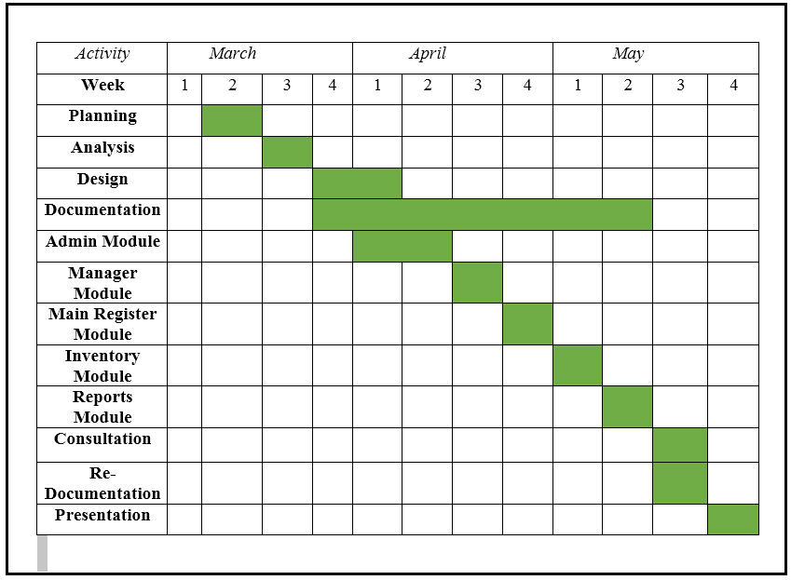
Figure 1. Gantt Chart
Shows the amount of work done in certain periods of time by the Researchers in relation to the amount of time planned for those periods.

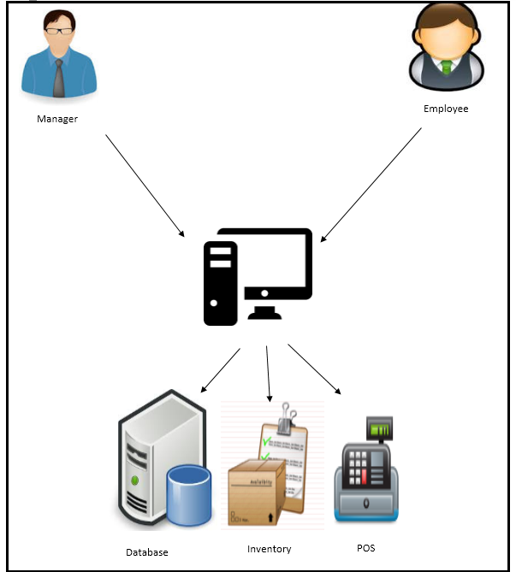
Figure 2. Architectural Design
Shows the Architectural Design of the proposed system “POS & Inventory System for Aj Trading Motorparts
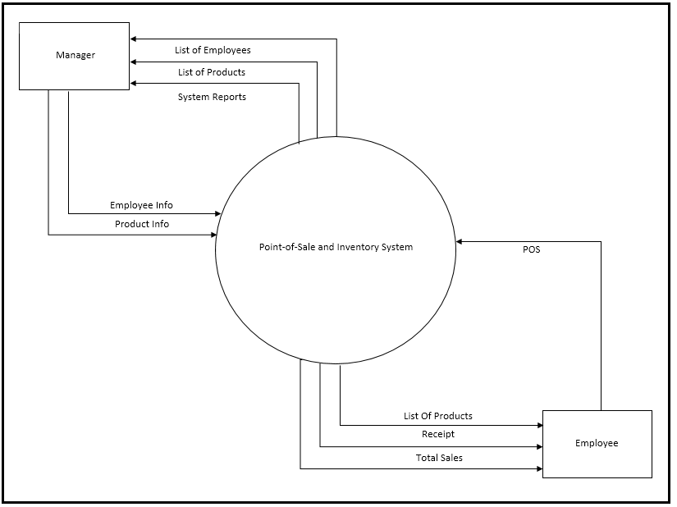
Figure 3. Context Diagram
Figure 3. Shows the Context Diagram of the Developed System. The Manager can add Employee accounts and add products.View list of employee, products and reports. While the employee account is use for Point-of-Sale

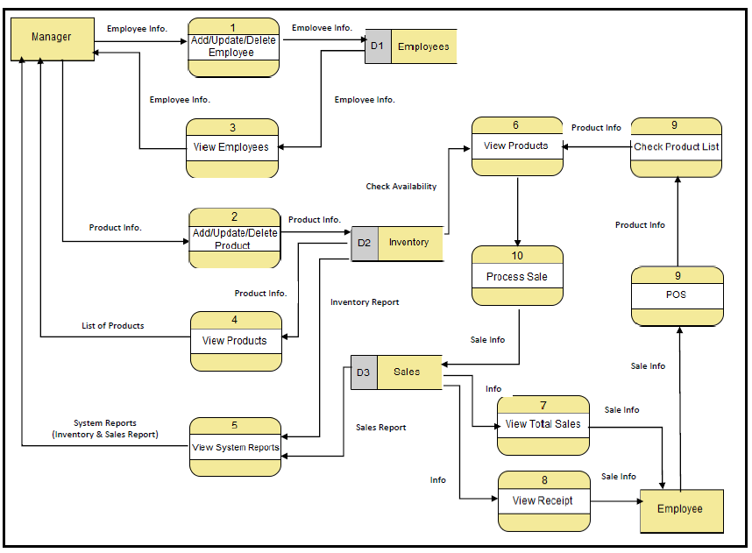
Figure 4. Data Flow Diagram
Figure 7. Shows the Top Level Data Flow Diagram of the developed system. It shows the flow of data from inputting of information of sales of the employee to generating the receipt for the customer and generation of report that can be viewed by the manager.
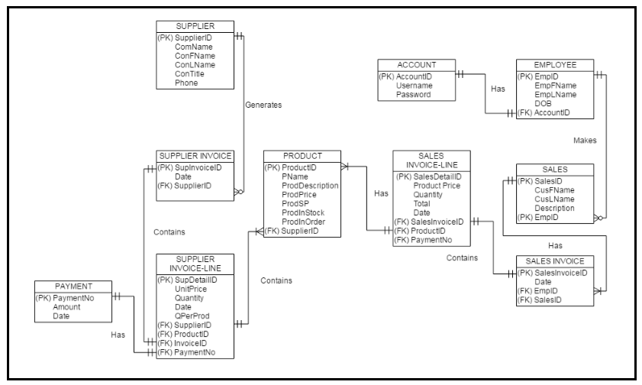
Figure 5. ER Diagram
Figure 5. Shows the Entity Relationship Diagram of the developed system and the relationships of entity sets stored in a database. It illustrate the logical structure of the database.

DEVELOPMENT METHODOLOGY

Figure 2. Agile Scrum Methodology
Agile Scrum
The researchers used the Agile Scrum Methodology in software Development. The researchers chose this methodology to adapt easily to changes, to be able to work side by side with end users and to make necessary corrections and adjustments quickly when certain requirements are altered. As Schwaber (2004) pointed out, the Scrum Agile methodology excels on urgent projects that are critical to an organization. He added that the scrum shortens the feedback loop between customer and developer, and between wish list and implementation. The process starts with the researchers interviewing the client for the requirements needed for the design of the system. This was followed by the release planning fits nicely into the planning frameworks that are often offered for scrum and identify the user’s story that they want to put in the release or sprint backlog. After that, the amount of work has been estimated and several sprints were created.
Planning
At the first stage of planning the session, the researchers have undergone a brainstorming session to identify the target locale and discussed the needs and arising problem within. The researchers discovered that the Aj Trading Motorparts is still using manual based system in making a sale and managing their inventory.
The researchers listed down the problems that the locale encountered and discussed them with the locale. After gathering the necessary data and requirements, the researchers created a Project Backlog to serve as a guide on creating the system. Then after that, the researchers initiated an estimation and prioritization planning session together with manager and loan officer. After that meeting, the researchers evaluated all the items that have been selected and then initiated the first Scrum Planning meeting.
Product Backlog
Product backlog is a part of Scrum terminology representing the prioritized list of requirements for the project being developed. The product backlog is the list of work the researchers must address during the next sprint. The list is derived by selecting the backlog items from the top of the backlog until the researchers feel it has enough work to fill the sprint. The backlog items are broken down into tasks by the researchers. Tasks on the sprint backlog are never assigned; rather, tasks are signed up by the researcher as needed according to the set priority and the researchers’ skills. This promotes self-organization of the researchers.
In listing the project backlog, the researchers had a meeting to talk over and analyzed the module that should be prioritized and included in every sprint. After a sprint has been done, the researchers got the feedback of their locale, and if there were some suggestions that were possible and can be included to the system, then these were included to the project backlog and subjected for the next sprint.

DATA DICTIONARY
Table 5. Supplier Table
PK/FK | Field Name | Data Type | Field Set | Description
PK | SupplierID | Int Auto | 30
 | ConFName | VarChar | 30 | Contact Person First Name
 | ConLName | VarChar | 30 | Contact Person Last Name
 | ConTitle | VarChar | 30 | Contact Person Title
 | Phone | VarChar | 15 | Phone Number

Table 6. Supplier Invoice Table
PK/FK | Field Name | Data Type | Field Set | Description
PK | SupInvoiceID | Int Auto | 30
 | Date | VarChar | 30 | Date of Transaction
FK | SupplierID | Int Auto | 30

Table 7. Supplier Invoice Line Table
PK/FK | Field Name | Data Type | Field Set | Description
PK | SupDetailID | Int Auto | 30
 | UnitPrice | VarChar | 30 | Product Price of the Supplier
 | Quantity | VarChar | 30 | Quantity of the Product
 | Date | VarChar | 30 | Date of Transaction
 | QperProd | VarChar | 15 | Quantity per Product on the list
FK | SupInvoiceID | Int Auto
FK | ProductID | VarChar
FK | PaymentNo. | Int Auto

Table 8. Payment Table
PK/FK | Field Name | Data Type | Field Set | Description
PK | PaymentNo | Int Auto | 30
 | Amount | VarChar | 30 | Amount to be Paid
 | Date | VarChar | 30 | Date of the Transaction

Table 9. Product Table
PK/FK | Field Name | Data Type | Field Set | Description
PK | ProductID | Int Auto | 30
 | Pname | VarChar | 30 | Product Name
 | ProdDescription | VarChar | 30 | Product Description
 | Prod Price | VarChar | 30 | Product Price
 | QperProd | VarChar | 15 | Quantity per Products
FK | SupInvoiceID | VarChar
FK | ProductID | VarChar
FK | PaymentNo. | Int Auto

Table 10. Sales Invoice Line Table
PK/FK | Field Name | Data Type | Field Set | Description
PK | SalesDetailID | Int Auto | 30
 | UnitPrice | VarChar | 30 | Product Selling Price
 | Quantity | VarChar | 30 | Quantity of the Product
 | Date | VarChar | 30 | Date of Transaction
 | QperProd | VarChar | 15 | Quantity per Product on the list
FK | SupInvoiceID | Int Auto
FK | ProductID | VarChar
FK | PaymentNo. | Int Auto

Table 11. Sales Invoice Table
PK/FK | Field Name | Data Type | Field Set | Description
PK | SalesInvoiceID | Int Auto | 30
 | Date | VarChar | 30 | Date of Transaction
FK | EmpID | Int Auto | 30
FK | SalesID | Int Auto | 30
FK | CustomerID | Int Auto | 30

Table 12. Sales Table
PK/FK | Field Name | Data Type | Field Set | Description
PK | SalesID | Int Auto | 30
 | Description | VarChar | 30 | Sales Description
FK | EmpID | Int Auto | 30

Table 13. Employee Table
PK/FK | Field Name | Data Type | Field Set | Description
PK | EmpID | Int Auto | 30
 | EmpFName | VarChar | 30 | Employee First Name
 | EmpLName | VarChar | 30 | Employee Last Name
 | DOB | VarChar | 30 | Date of Birth
FK | AccountID | Int Auto | 30

Table 14. Account Table
PK/FK | Field Name | Data Type | Field Set | Description
PK | AccountID | Int Auto | 30
 | Username | VarChar | 30 | Account Username
 | Password | VarChar | 30 | Account Password

Table 15. Costumer Table
PK/FK | Field Name | Data Type | Field Set | Description
PK | CustomerID | Int Auto | 30
 | CustomerFName | VarChar | 30 | Customer First Name
 | CustomerLName | VarChar | 30 | Customer Last Name
 | CustomerMI | VarChar | 30 | Customer Middle Initial

